Results and Discussion Outline

Section I: Post-ETL Master Descriptive Statistics

1.1 Purpose & Scope
This section establishes the empirical baseline of the entire research warehouse immediately following raw data ingestion, automated cleaning, surrogate key transformation, and relational joining.
- Documents every post-ETL data point across the complete, nationwide commercial aviation network (covering 25 candidate commercial airfields and 955 individual physical checkpoint lanes over the continuous 7-year period from January 1, 2019 to December 31, 2025).
- Total Post-ETL Cleaned Warehouse Volume: 42,062,039 conformed records synthesized from 67,222,828 raw upstream government records.
1.2 Post-ETL Master Descriptive Statistics
The following parametric and non-parametric statistics characterize EVERY data point post-ETL across the complete nationwide network:
- TSA Checkpoint Hourly Throughput
- Domestic Flight Operational Characteristics
- BTS Form 21 Schedule T-100 Route Capacity
- BTS DB1B Ticket Itinerary Survey

Section II: Filtering Pipeline
1. Scale

4. Orthogonal Factorial Cohort (The 9 Selected Airfields):
- Final Cohort: BOS, DFW, DTW, EWR, IAH, LAX, LGA, ORD, PHL
- Factorial Balance: Exactly 4 dedicated terminal screening environments per legacy carrier:
- American Airlines (AA): 4 (BOS-B, DFW-D, ORD-T3, PHL-B/C)
- Delta Air Lines (DL): 4 (BOS-A, DTW-McNamara, LAX-T2/T3, LGA-TC)
- United Airlines (UA): 4 (EWR-C, IAH-C, ORD-T1, LAX-T7)
Specific Exclusions & Inclusions:
- LGA vs. JFK: United permanently vacated JFK in October 2022 (failing Meso temporal continuity), whereas LGA opened Delta's consolidated Terminal C in June 2022, providing unconfounded screening lanes.
- PHL vs. SLC: Salt Lake City funnels all carriers through a single consolidated screening making carrier isolation impossible. Philadelphia (PHL) provides dedicated AA checkpoints (Terminals B and C).
V2 Results
Findings
Phase 1: Initial Dataset

Descriptive Statistics
- Characteristics of volatility
  - OTP: Arrival delay experiences right tail skewness, as en-route flight padding collapses during severe downline disruptions & weather is the most volatile delay cause
- Seasonality
- Relationship between TSA and OTP
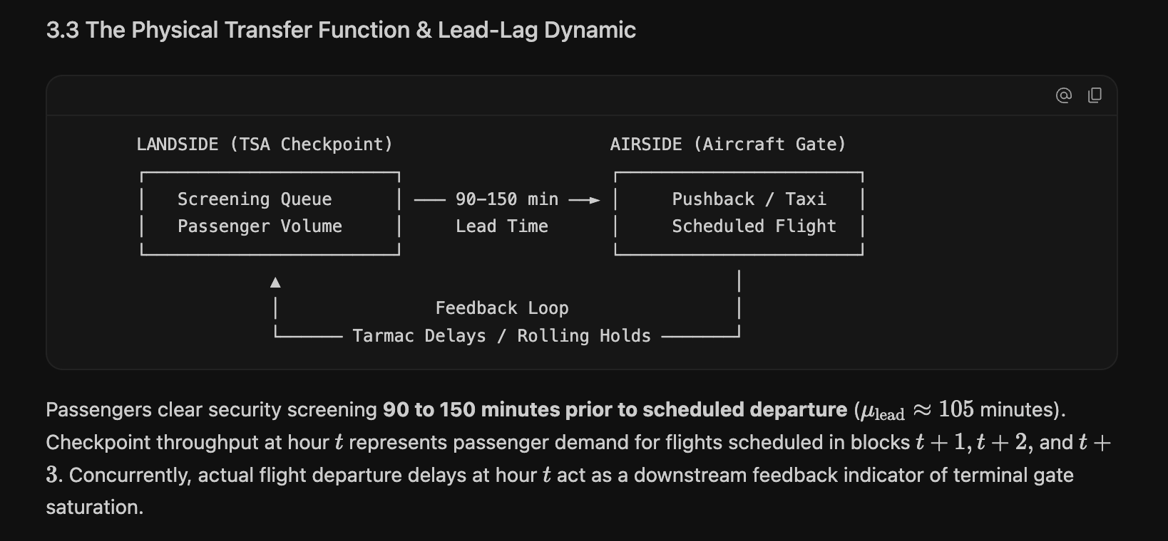

Implications
- Load factor inclusion (account for connecting PAX)
  - Naive linear model exhibits modest correlation (r-squared .2090 for p<.05)
  - “Connecting Ratio Paradox” - sometimes high flight volume and low TSA throughput for many connecting flights, and sometimes low flight volume and high tsa throughput)
  - Resolution: 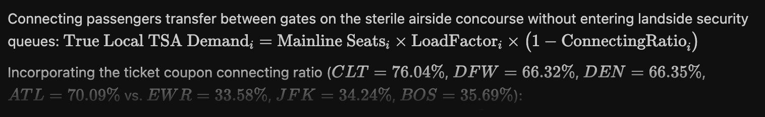

- Checkpoint exclusivity (increase confidence in TSA<>OTP relationship)
- Balanced spatial and operational archetypes (eliminate structural confounding)

Four Tiered Purpose Filtering Pipeline
- Macro: Systemic Scale & Throughput Volume
- Mesco: Legacy Carrier Co-Location
- Micro: Causal Identification via Checkpoint Exclusivity
- Experimental Transfer Filter (Balanced Experimental Design)

Phase II: Filtered Dataset

Descriptive Statistics
- Characteristics of variance
- Seasonality
- Relationship between TSA and OTP

Implications
- Representative model selection
- Model development
- Feature Engineering, Training, & Testing

Phase III: Model Execution & Performance Evaluation

Descriptive Statistics
- Deterministics Baseline: SARIMAX
- Probabilistic/Data-Driven ML: Gradient Boosting Decision Trees
- Dynamic Hybrid: Sequential Two-Stage SARIMA-Quantile Tree Hybrid

Performance Evaluation
- Robustness
- Resilience
- Generalizability
V2 Detailed Outline

Phase 1. ETL (Extract, Transform, Load)

Data Profile → To be moved to the methodology
- Top 25 airports (used as standard); 26,521,405 flights

Descriptive Statistics (Top 25 Airports)

- Basic → All 4 datasets?
- Trends in volatility of data
- TSA
- OTP
- Relationship between volatility of TSA and OTP
  - “Passengers clear security screening 90 to 150 minutes prior to scheduled departure, mu-lead about 105m” Checkpoint throughput at hour t represents pax demand for flights scheduled in blocks.
  - Concurrently, actual flight departure delays at hour t act as a downstream feedback indicator of terminal gate saturation.

TSA
Seasonality
Intraday Temporal Arrival Banks:
- Morning Departure Bank (04:00 - 07:00): Represents the most concentrated landside passenger influx, driven by passengers arriving for 06:00 to 08:30 aircraft pushbacks.
- Midday Bank (11:00 - 14:00): Characterized by sustained passenger throughput for transcontinental and midday hub connection banks.
- Evening Bank (16:00 - 19:00): Secondary peak serving evening business departures and outbound long-haul flights.
- Overnight Inactivity (00:00 - 03:59): Dominated by scheduled lane shutdowns with minimal baseline screening.

METRICS
- Standard parametric
- Non-parametric: Interquartile, range, quartile coefficient of dispersion, percentiles, skewness, kurtosis
  - “Skewness measures the asymmetry of a data distribution, while kurtosis measures the heaviness of its tails relative to the center”

Phase 2: Criteria Analysis

2a. Temporal Boundary

2b. Four Tiered Purpose Filtering Pipeline
- Macro: Systemic Scale & Throughput Volume (Macro Filter)
- Mesco: Legacy Carrier Co-Location (Meso Filter)
- Micro: Causal Identification via Checkpoint Exclusivity (Micro Filter)
- Experimental Transfer Filter (Balanced Experimental Design)
  - Exactly four dedicated, carrier-exclusive checkpoint environments for each of the three legacy carriers (AA: 4, DL: 4, UA: 4)
  - 4 empirical operational clusters (Mega-Connecting Gateways, High-Density O&D Focus, High-Reliability Fortress Hubs, and Congested Coastal Originators)
  - 4 terminal physical archetypes (Decentralized, Linear Mega-Concourse, Multi-Terminal Ring, and Satellite).

The Spatial & Temporal Filtering Pipeline
- Econometric Validation
- Operational Clustering & Connecting Ratio Paradox

Section 3. Descriptive Statistics of the Filtered Experimental Dataset

Section 4. REPRESENTATIVE MODEL SELECTION & HYPOTHESIS-ALIGNED SPECIFICATION

